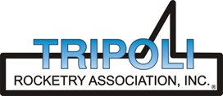
Tripoli Motor Testing Division
223 NC Highway 54 West
Chapel Hill, NC 27514
(919) 357 5681 (c)
May 12, 2018

Gary Rosenfield
RCS Rocket Motor Components, Inc.
2113 West 850 North Street
Cedar City, UT 84721

Dear Mr. Rosenfield,

The Quest Q-Jet D16-4,6,8FJ single-use motor was tested on May 2, 2018 and is in compliance with NFPA 1125. The motor is certified for hobby rocketry use by the members of the Tripoli Rocketry Association and all approving organizations with reciprocal certifying agreements.

Motor Manufacturer Quest Division, RCS Rocket Motor Components
Manufacturer’s Designation D16-4,6,8FJ [18mm single use]
Propellant Black Max
TMT Nomenclature 12 D16

Diameter - 18 mm
Overall Length 3.137” 79.7 mm
Case Length 2.706” 68.7 mm

Loaded Mass .0565 lb 25.6 g
Propellant Mass .0276 lb* 12.5 g*
Burnout Mass .0290 lb 13.1 g

Burn time 0.792 ± .025 sec

Total Impulse 2.781 ± .069 lbf.s 12.37 ± .31 N.s
Max Impulse 5.103 ± .221 lbf 22.3 ± 0.98 N
Average Impulse 3.506 ± .158 lbf 15.60 ± .70 N
Number of Motors Tested 11
Nominal Measured
Delay Time Data 4 s 4.01, 4.219, 4.764 sec
6 s 6.455, 6.644, 6.354, 5.663 sec
8 s 7.274, 9.012, 6.945, 7.891 sec

Casing Temp. [NFPA 1125 7.4.1] Passed

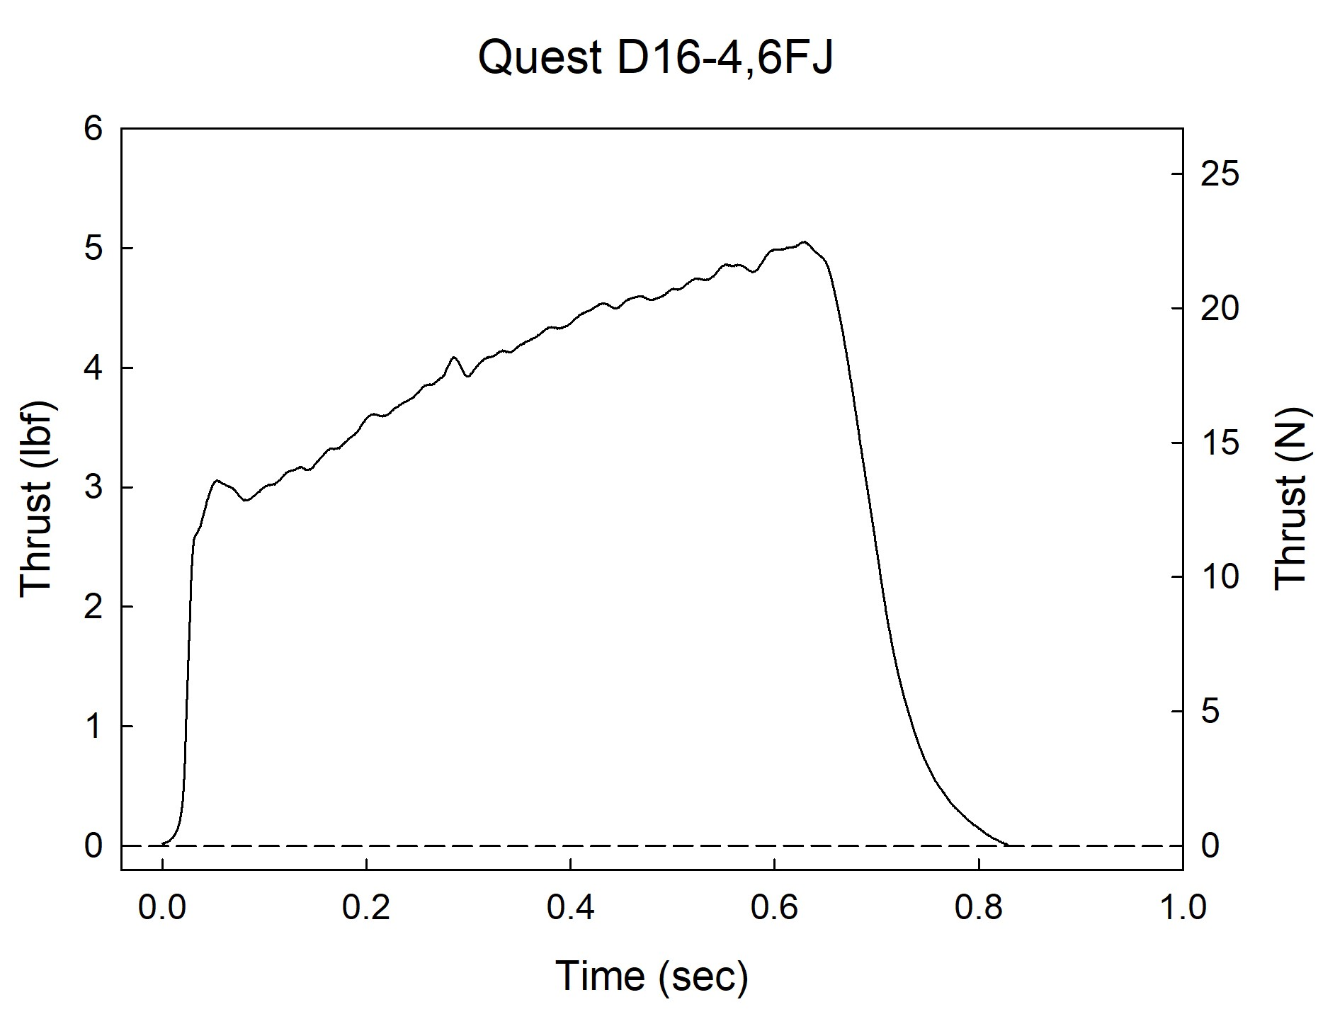

Sincerely,

Alan C. Whitmore
Chair, Tripoli Motor Testing

